PURSUING SDG TARGET 12.3:
Guidance on interpreting Sustainable Development Goal Target 12.3

Prepared by Craig Hanson (WRI) with input from colleagues and experts working on issues relating to food loss and waste

THE OPPORTUNITY
Food intended for human consumption that is lost or wasted is a challenge of epic proportions. According to the best available global estimates compiled by the Food and Agriculture Organization of the United Nations (FAO), approximately one-third of all food produced in the world in 2009 was lost or wasted. This huge level of inefficiency has substantial impacts. It results in roughly $940 billion in economic losses globally per year. It contributes to food insecurity and hinders nutrition—in a world where one in nine people are undernourished. In fact, food loss and waste results in a 24 percent reduction in available food calories—driven by grains—and an untold reduction in nutrients, particularly given that fruits and vegetables are the most frequently lost or wasted food group by weight. In addition, food that is harvested but ultimately lost or wasted consumes about one-quarter of all water used by agriculture each year, requires cropland area greater than the size of China, and generates about 8 percent of global greenhouse gas emissions annually.

Reducing food loss and waste, therefore, can generate a “triple win.” It can save money for farmers, companies, and households. It can help feed more people. And it can alleviate pressure on water, land, and climate.

Recognizing this potential, the United Nations General Assembly highlighted food loss and waste reduction as a priority for the global agenda. In September 2015, countries of the world formally adopted a set of 17 Sustainable Development Goals (SDGs)—global goals to end poverty, protect the planet, and ensure prosperity for all—as part of the 2030 Agenda for Sustainable Development. For these goals and targets to be achieved, everyone needs to do their part: governments, the private sector, and civil society. Although countries have the primary responsibility for follow-up and review of progress toward these goals, actions by the private sector and citizens also will be critical to achieving the SDGs.

Each goal has a set of targets to be achieved by 2030. SDG 12 seeks to “ensure sustainable consumption and production patterns.” The third target under this goal, Target 12.3, states:

“By 2030, halve per capita global food waste at the retail and consumer levels
and reduce food losses along production and supply chains, including post-harvest losses.”

THE AMBIGUITY
However, conversations with many people indicate that, in several respects, the exact meaning of SDG Target 12.3 is somewhat ambiguous. In particular:
- It is not explicit whether it covers the entire food supply chain, including sectors such as food manufacturing, hospitality, and food service.
- Although it has a quantified target for “food waste,” it does not have a quantified target for “food losses.”
- It is unclear whether the target covers only food or both food and its associated inedible parts (e.g., bones, rinds, pits/stones).
- It is unclear which destinations (e.g., sewer, landfill, composting, animal feed) constitute “losses” and “waste.”
- The existing United Nations (UN) “indicator” for monitoring country progress toward SDG Target 12.3—the Food Loss Index—only covers the food loss portion of the target, not the food waste portion.

This ambiguity has the potential to create uncertainty among governments, companies, and civil society about what they should be aspiring to achieve. Uncertainty can breed inaction. It can complicate measuring progress toward the target and comparing results. And it can hinder ambition, since entire sectors might think they are excluded, or entities might not consider certain destinations as “food loss and waste” and thus not take action where appropriate.

THE CLARIFICATION
In response to this ambiguity, this document proposes the following as an appropriately ambitious interpretation of the SDG target on food loss and waste. Clearly it is not possible to add to or change the actual wording of Target 12.3, since all the SDG targets were formally agreed upon in 2015 by member countries of the United Nations after a multiyear process. Nonetheless, the interpretation below could be considered “best practice” or a “north star” for how governments and companies should interpret SDG Target 12.3. This elaboration can guide governments (e.g., country, provincial, city), companies, and citizens as they set explicit food loss and waste reduction targets, measure progress, and take on-the-ground action.
- What sectors are covered? One should interpret Target 12.3 as covering the entire food supply chain, from the point that crops and livestock are ready for harvest or slaughter through to the point that they are ready to be ingested by people (Figure 1). Entities should seek to reduce food loss and waste within the boundaries they control, and seek to help drive reductions up and down the supply chains where they have influence.
- What is the target for food losses? If the world is to fully realize the economic, food security, and environmental benefits of reducing food loss and waste, one should apply the “halve per capita” in practice to food losses, as well, not just to food waste. Not having a quantitative target on the food loss portion risks reducing both ambition and focus on an issue (food losses) that is important for many regions of the world.
- What material types count? One should interpret that “food loss and waste” applies to both “food” that is intended for human consumption and its associated “inedible parts” which leave the human food supply chain because Target 12.3 comes under SDG 12 (“sustainable consumption and production”) and not SDG 2 (“ending hunger”). It is thus about food security and resource-use efficiency, and not just about food security alone. This recommendation is consistent with the draft scope proposed for country-level data being suggested by FAO and the European Commission.
- What destinations count? One should interpret that “loss and waste” covers eight of the possible destinations for food and associated inedible parts that leave the human food supply chain (see the appendix for definitions of possible destinations). It excludes animal feed and bio-based materials/biochemical processing (where material is converted into industrial products) (Figure 2). This recommendation on defining “food loss and waste” is consistent with the approach proposed by FAO and the European Commission for country-level reporting, except that these two organizations also exclude “not harvested/plowed-in” due to data availability and regulatory constraints, respectively.
The challenge in collecting data on crops that are ready for harvest but are ultimately not harvested is real. However, including “not harvested/plowed-in” in the scope is important for inspiring interest in collecting this data, as well as for inspiring innovations that reduce this type of food loss. If countries currently do not collect this data, then there may be a role for the private sector when engaging suppliers on food loss and waste issues; that is, private sector data could complement government data. Moreover, not harvesting crops that are otherwise ready for harvest is a waste of numerous resources. Best practice strategies do exist for avoiding this destination such as gleaning and better food demand forecasting.
- What indicator should be used? For monitoring of country progress toward SDG Target 12.3, the indicator ideally should be “food loss and waste per capita” (based on a country’s population), measured in kilograms/person/year. This would be substantiated by two sub-indicators, one focusing on losses occurring from the farm up to (but excluding) the retail stage of the food value chain (the existing “Food Loss Index”), and the other focusing on waste from retail to the point of consumption (a to-be-developed “Food Waste Index”). This solution ensures full coverage of the food loss and waste issue and existing language of SDG Target 12.3, yet minimizes the reporting burden. FAO has been chosen to serve as custodian for the indicator.

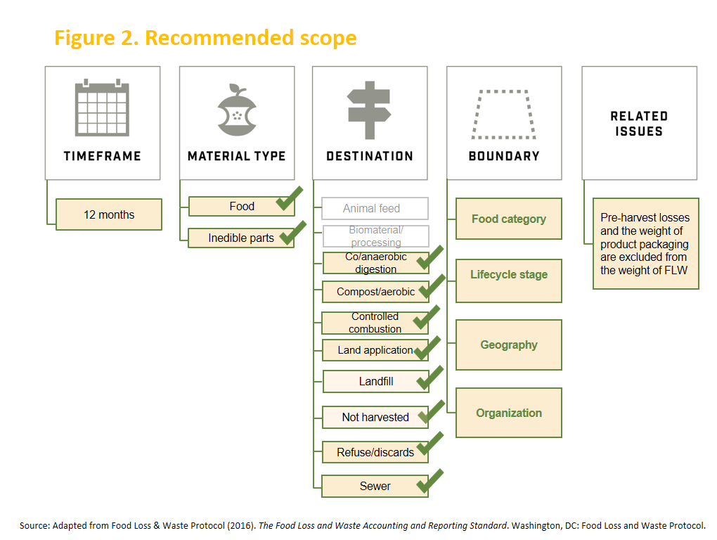

This interpretation means that SDG Target 12.3 is challenging the world to cut in half the amount of food and associated inedible parts per capita that is not eaten and ends up in destinations other than animal feed or bio-based materials/biochemical processing. This means that:
- Achieving the target involves preventing food and associated inedible parts from leaving the human food supply chain in the first place (e.g., avoiding excess food production, ensuring food makes it to market, donating or redistributing unsold food to those in need, converting inedible parts into food) and/or by shifting that which does leave the human food supply chain away from less value-added destinations and instead toward animal feed or bio-based materials/biochemical processing.
- The 50 percent reduction target applies to both food and associated inedible parts. However, if entities are able to measure and report on food and associated inedible parts separately, then they should be able to apply the 50 percent reduction target only to the food portion—although they should still take steps to reduce the amount of inedible parts as much as possible. This flexibility recognizes that for some entities a significant share of food loss and waste may be associated inedible parts. Yet halving the amount of inedible parts can be more difficult to achieve than halving the amount of food, since there can be physical, cultural, or regulatory limitations on inedible parts being converted into food, diverted to animal feed, and/or diverted to bio-based materials/ biochemical processing. This flexibility creates an incentive for entities to quantify food and associated inedible parts separately.
- When accounting for and reporting a food loss and waste inventory to meet Target 12.3, entities should select a scope consistent with the material types and destinations outlined in Figure 2. The Food Loss and Waste Accounting and Reporting Standard can help companies, countries, cities, and others by providing common definitions and language to describe the scope, as well as guidance on available quantification methods. Of course, entities may elect to expand the scope (to cover more destinations) if doing so helps them meet other goals beyond SDG Target 12.3 (e.g., an industry association voluntary target). An efficient approach is to quantify data and record results separately per destination for all destinations in Figure 2. Doing so empowers an entity to gain insights on all its food-related material flows and retain the ability to easily share or report results for multiple food loss and waste programs, including achieving SDG Target 12.3, that may have different scopes.

There already is a hierarchy among the suite of destinations in terms of which generate the most value for people and the planet. Although there are slight variations around the world, Figure 3 gives a perspective on this hierarchy.

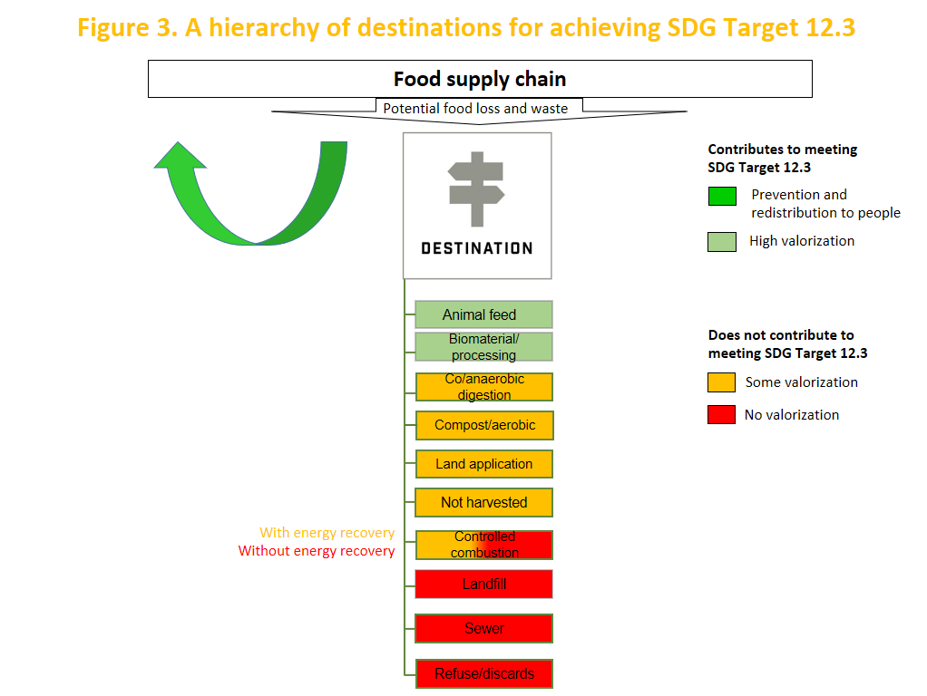

THE ASPIRATION
These recommendations are designed to help governments and companies more effectively, confidently, and consistently set food loss and waste reduction targets and measure performance over time. They are designed to help governments and companies set their scopes when conducting food loss and waste inventories. In addition, they are designed to provide input into the ongoing process for developing and refining indicators for tracking the SDGs.

SDG Target 12.3 is a once-in-a-generation call to action. Governments and companies should adopt this target as their own, start measuring to manage, and boldly take action. If we all do this, we will take a big step toward a future that improves economic performance, achieves food security, strengthens social conditions, promotes resource-use efficiency, protects the planet, and contributes to prosperity for all.

APPENDIX

Definitions of “food” and “inedible parts”
“Food” is any substance—whether processed, semi-processed, or raw—that is intended for human consumption. Food includes drink, and any substance that has been used in the manufacture, preparation, or treatment of food. Food also includes material that has spoiled and is therefore no longer fit for human consumption. It does not include cosmetics, tobacco, or substances used only as drugs. It does not include processing agents used along the food supply chain, for example, water to clean or cook raw materials in factories or at home.

“Inedible parts” are components associated with a food that, in a particular food supply chain, are not intended to be consumed by humans. Examples of inedible parts associated with food could include bones, rinds, and pits/stones. Inedible parts do not include packaging. What is considered inedible varies among users (e.g., chicken feet are consumed in some food supply chains but not in others), changes over time, and is influenced by a range of variables, including culture, socioeconomic factors, availability, price, technological advances, international trade, and geography.

Definitions of destinations
“Destinations” are where food and/or associated inedible parts that leave the human food supply chain go. The destinations below are presented in alphabetical order and are focused on the processes used to convert material exiting the food supply chain rather than on the ultimate output (e.g., fuel, soil amendment). See Chapter 6 of the FLW Standard for additional detail.

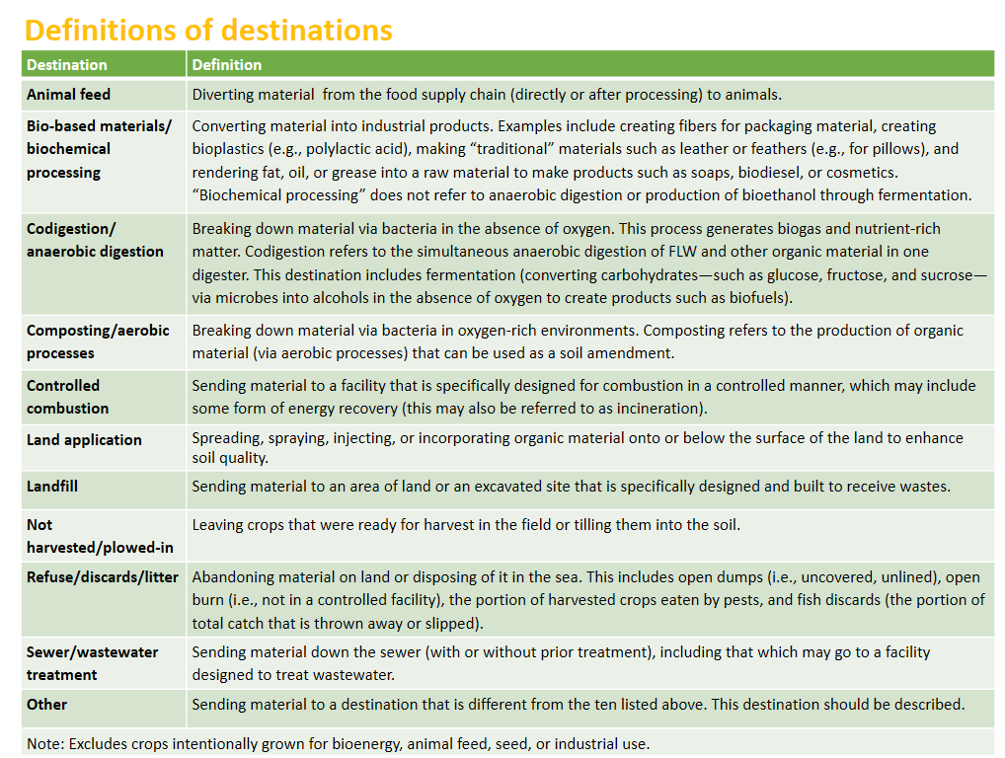
NOTES

One-third as measured by weight. FAO (Food and Agriculture Organization of the United Nations). 2011. Global food losses and food waste – extent, causes and prevention. Rome: UN FAO.
FAO. 2015. Food wastage footprint & climate change. Rome: UN FAO.
World Food Programme. 2016. “Hunger Statistics.” Accessible at: <https://www.wfp.org/hunger/stats>.
Lipinski, B. et al. 2013. Reducing Food Loss and Waste. Working Paper. Washington, DC: World Resources Institute.
Kummu, M., H. de Moel, M. Porkka, S. Siebert, O. Varis, and P.J. Ward. 2012. “Lost food, wasted resources: Global food supply chain losses and their impacts on freshwater, cropland, and fertiliser use.” Science of the Total Environment 438: 477–489.
FAO (Food and Agriculture Organization of the United Nations). 2013. Food wastage footprint: impacts on natural resources. Rome: UN FAO.
FAO. 2015. Food wastage footprint & climate change. Rome: UN FAO.
See http://www.un.org/sustainabledevelopment/sustainable-development-goals/#
The United Nations does not track province, city, or company progress toward the Sustainable Development Goals. The Food Loss and Waste Accounting and Reporting Standard provides guidance for provinces, cities, and companies (as well as countries) on food loss and waste accounting and reporting.
This gap is recognized by the Food and Agriculture Organization of the United Nations (FAO), which has stated, “The food waste component of target SDG 12.3 is not covered at all by this indicator,” and that there is “the need to have an additional indicator for the SDG 12.3 that will focus on monitoring the food waste component.” Tayyib, S., and N. Golini. 2016. “The FAO approach to food loss concepts and estimation in the context of Sustainable Development Goal 12 Target 3.” Discussion Paper. Rome: UN FAO.
“Food” does not include crops grown with the intention of becoming animal feed, biofuels, or other non-food uses.
How to select a quantification method for a food loss and waste inventory is described in chapter 7 of The Food Loss and Waste Accounting and Reporting Standard (2016). A companion document, Guidance on FLW Quantification Methods, provides an overview of ten ways in which an entity may obtain, quantify, record, and analyze data for an FLW inventory.
See FLW Protocol. 2016. The Food Loss and Waste Accounting and Reporting Standard. Washington, DC: Food Loss and Waste Protocol.
See FLW Protocol. 2016. The Food Loss and Waste Accounting and Reporting Standard. Washington, DC: Food Loss and Waste Protocol.

